{{givenName}} {{surname}}
{{address}}

Dear {{salutation}} {{surname}}:

We've noticed that you haven't had your hearing checked in about a year.

Over time your hearing will change, and we recommend you have an annual assessment to make sure you are getting the most from your hearing.

Based on an updated hearing evaluation, we at {{clinicName}} can help ensure that you are getting the most from your hearing.

Call us today at {{clinicPhoneNumber}} to schedule an appointment.

Sincerely,

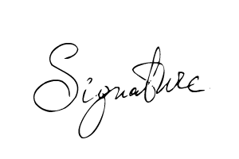
{{signer_firstname}} {{signer_lastname}}, {{signer_qualifications}}
{{signer_jobTitle}}

