Patient (Last Name) | (First Name) | (Initial) | Date of Birth
{{surname}}[fd] | {{givenName}}[fd] | {{initial}}[fd] | {{birthdate}}[fd]
Address Street |  | City/Town | Province/State
{{streetNo}} {{street}} {{unit}}[fd] |  | {{city}}[fd] | {{province}}[fd]
Postal Code | Telephone Number |  | Date of Service
{{postalCode}}[fd] | {{phoneNumber}}[fd] |  | {{audiogramDate}}[fd]

Case History
[fdm:Case History]
Puretone Audiometry | Speech Audiometry | Discrimination Loss

   |  | SAT | SRT | Mask | MCL | UCL |  | WR % | WR Level | WR Mask |  | WRN % | WRN Level | WRN Mask
   | R | [fd] | {{SRT_Right}}[fd] | {{SRT_Right_Mask}}[fd] | {{MCL_Right}}[fd] | {{UCL_Right}}[fd] |  | {{WR_Right_Percent}}[fd] | {{WR_Right_Level}}[fd] | {{WR_Right_Mask}}[fd] |  | {{WRN_Right_Percent}}[fd] | {{WRN_Right_Level}}[fd] | {{WRN_Right_Noise}}[fd]
   | L | [fd] | {{SRT_Left}}[fd] | {{SRT_Left_Mask}}[fd] | {{MCL_Left}}[fd] | {{UCL_Left}}[fd] |  | {{WR_Left_Percent}}[fd] | {{WR_Left_Level}}[fd] | {{WR_Left_Mask}}[fd] |  | {{WRN_Left_Percent}}[fd] | {{WRN_Left_Level}}[fd] | {{WRN_Left_Noise}}[fd]
  Bi |  | [fd] | {{SRT_Binaural}}[fd] |  | {{MCL_Binaural}}[fd] | {{UCL_Binaural}}[fd] |  | {{WR_Binaural_Percent}}[fd] | {{WR_Binaural_Level}}[fd] |  |  | {{WRN_Binaural_Percent}}[fd] | {{WRN_Binaural_Level}}[fd] | {{WRN_Binaural_Noise}}[fd]
  Tympanograms
  Pressure mmH20
   | Left |  | Right
   | Type | [fd]{{tympanometryTypeLeft}} | Type | [fd]{{tympanometryTypeRight}}
   | Pressure | [fd]{{tympanometryMEPressureLeft}} | Pressure | [fd]{{tympanometryMEPressureRight}}
   | Compliance | [fd]{{tympanometryComplianceLeft}} | Compliance | [fd]{{tympanometryComplianceRight}}
   | Volume | [fd]{{tympanometryVolumeLeft}} | Volume | [fd]{{tympanometryVolumeRight}}
   | 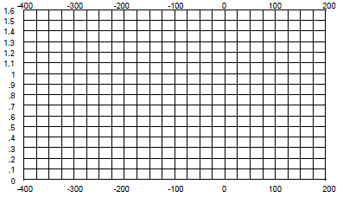

Results

Recommendations

Signature: | 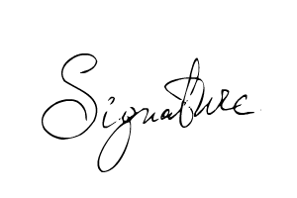 | Lic.No: {{provider}} | Date: 7/28/26
Print Name: | {{signer_firstname}} {{signer_lastname}}, {{signer_qualifications}}

