7/28/2026

{{recipient_salutation}} {{recipient_givenName}} {{recipient_surname}}
{{recipient_address}}
Fax: {{recipient_faxNo}}

Dear {{recipient_salutation}} {{recipient_surname}}

Patient Name: {{givenName}} {{surname}}
Date of Birth: {{birthdate}}

Your patient was seen in our office for an audiological assessment and/or hearing aid evaluation. Enclosed is a copy of the audiogram and an interpretation of the results for your files. I would be happy to answer any questions you may have concerning these test results.[fdm:Letter]
Regards,
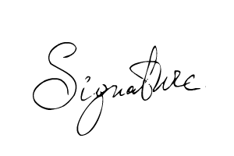
{{signer_firstname}} {{signer_lastname}}, {{signer_qualifications}}
{{signer_jobTitle}}
{{clinicName}}

