7/28/2026

{{patientPhysicianNameCombined}}
{{patientPhysicianAddress}}
Fax: {{patientPhysicianFaxNumber}}

Dear {{patientPhysicianSalutation}} {{patientPhysicianSurname}},

Patient Name: {{givenName}} {{surname}}
Date of Birth: {{birthdate}}

Your patient was seen in our office for an audiological assessment and/or hearing aid evaluation. Enclosed is a copy of the audiogram and an interpretation of the results for your files. I would be happy to answer any questions you may have concerning these test results.[fdm:Letter]
Regards,
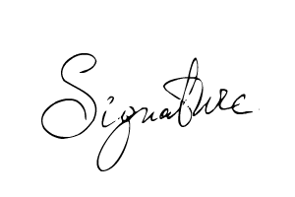
{{signer_firstname}} {{signer_lastname}}, {{signer_qualifications}}
{{signer_jobTitle}}
{{clinicName}}

Patient (Last Name) | (First Name) | (Initial) | Date of Birth
{{surname}}[fd] | {{givenName}}[fd] | {{initial}}[fd] | {{birthdate}}[fd]
Address Street |  | City/Town | Province/State
{{streetNo}} {{street}} {{unit}}[fd] |  | {{city}}[fd] | {{province}}[fd]
Postal Code | Telephone Number |  | Date of Service
{{postalCode}}[fd] | {{phoneNumber}}[fd] |  | {{audiogramDate}}[fd]

Puretone Audiometry
 | Speech Audiometry
 | SRT | Mask | MCL | UCL
R | {{SRT_Right}}[fd] | {{SRT_Right_Mask}}[fd] | {{MCL_Right}} [fd] | {{UCL_Right}}[fd]
L | {{SRT_Left}}[fd] | {{SRT_Left_Mask}}[fd] | {{MCL_Left}}[fd] | {{UCL_Left}}[fd]
Binaural | {{SRT_Binaural}}[fd] | [fd] | {{MCL_Binaural}}[fd] | {{UCL_Binaural}}[fd]

 | % Stimulus Mask
 | WR % | WR Level | WR Mask
R | {{WR_Right_Percent}}[fd] | {{WR_Right_Level}}[fd] | {{WR_Right_Mask}}[fd]
L | {{WR_Left_Percent}}[fd] | {{WR_Left_Level}}[fd] | {{WR_Left_Mask}}[fd]
Binaural | {{WR_Binaural_Percent}}[fd] | {{WR_Binaural_Level}}[fd] | [fd]

 | % Stimulus Noise
 | WRN % | WRN Level | WRN Mask
R | {{WRN_Right_Percent}}[fd] | {{WRN_Right_Level}}[fd] | {{WRN_Right_Noise}}[fd]
L | {{WRN_Left_Percent}}[fd] | {{WRN_Left_Level}}[fd] | {{WRN_Left_Noise}}[fd]
Binaural | {{WRN_Binaural_Percent}}[fd] | {{WRN_Binaural_Level}}[fd] | {{WRN_Binaural_Noise}}[fd]

 | 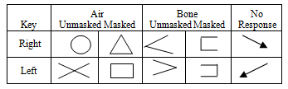
Tympanograms  Pressue mmH2O | Results/Comments
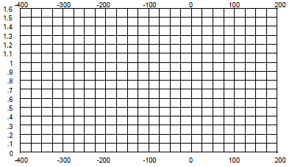 | [fdm:Results/Comments]
 | Recommendations
 | [fdm:Recommendations]
  Left |  |  | Right
  Type | [fd]{{tympanometryTypeLeft}} |  | Type | [fd]{{tympanometryTypeRight}}
  ME Pressure | [fd]{{tympanometryMEPressureLeft}} |  | ME Pressure | [fd]{{tympanometryMEPressureRight}}
  Compliance | [fd]{{tympanometryComplianceLeft}} |  | Compliance | [fd]{{tympanometryComplianceRight}}
  Volume | [fd]{{tympanometryVolumeLeft}} |  | Volume | [fd]{{tympanometryVolumeRight}}

