Date: July 31, 2026

{{recipient_salutation}} {{recipient_givenName}} {{recipient_surname}}
{{recipient_address}}

RE: {{givenName}} {{initial}} {{surname}}
DOB: {{birthdate}}

Dear {{recipient_salutation}} {{recipient_surname}},

I am writing to thank you for your recent referral. We are committed to providing the highest level of hearing healthcare to your patients and sincerely appreciate your confidence in us.

Please contact me at anytime if I can be of any further assistance. Once again, thank you for your referral.[fdm:letter]

Best regards,
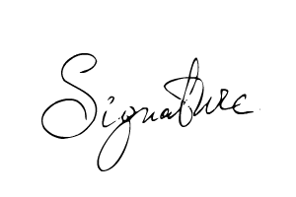
{{signer_firstname}} {{signer_lastname}}, {{signer_qualifications}}
{{signer_jobTitle}}

