{{givenName}} {{surname}}
{{address}}

Dear «givenName» «surname»,

Revolutionary new hearing technology now available.

Since you were last fit with your hearing instruments, I have had the opportunity to fit patients with remarkable new hearing devices. When I saw the capabilities and unique design, I thought this would be the perfect opportunity for you.

With this new technology, patients have reported a more comfortable, more natural listening experience. With these instruments you can take advantage of an array of easy-to-use Bluetooth solutions as well. Please call us at {{clinicPhoneNumber}} if you would like to apply for a risk-free trial.

Sincerely,
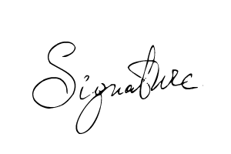

{{signer_firstname}} {{signer_lastname}}, {{signer_qualifications}}
{{signer_jobTitle}}

