{{givenName}} {{surname}}
{{address}}

Dear {{salutation}} {{surname}},

Your warranty is about to expire – Extended coverage available!

We have appreciated the opportunity to assist with your hearing health needs, and we hope you have enjoyed the benefits of better hearing. Our records indicate the warranty on your hearing instrument will expire on: {{aux1}}

This is a good time to consider our Warranty Renewal program in order to extend the warranty on your hearing instrument. This will ensure your peace of mind and free-of-charge service on your hearing instrument.

A one year extended warranty is available for only $295.00 per hearing aid. Please contact our office to extend your warranty coverage. Call us today at {{clinicPhoneNumber}}.

Sincerely,
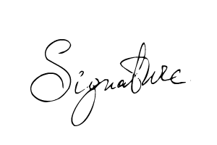
{{signer_firstname}} {{signer_lastname}}, {{signer_qualifications}}
{{signer_jobTitle}}

