Hearing Care is Health Care™

Dear {{givenName}},

Your hearing is one of your most valuable assets, but you may not realize the importance that hearing health has on your overall well-being. Untreated hearing loss can have a negative effect on your overall health and cognition. Science shows that we hear with our brains and not our ears so having a hearing aid that supports your brain is essential.

That’s why I’m excited to tell you about new technology that takes hearing healthcare to a new level. Oticon More™ with BrainHearing™ technology is a revolutionary hearing device that gives the brain more of the relevant information it needs to make better sense of sound, so you get better speech understanding with less effort and the ability to remember more.

That helps you stay connected to family and friends, which is more important than ever. Oticon More also connects to your favorite technology with direct streaming from iPhone®, iPad® and Android™* devices.
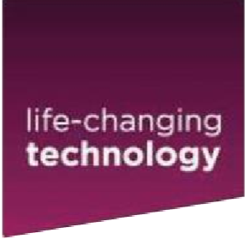
It’s powered by a rechargeable battery that lasts all day** so you can talk on the phone or listen to music with confidence that your hearing device will keep up with you, even on the busiest days.

I know that one of the biggest challenges you experience is following conversations – especially in noisy environments. This new technology is designed to support your brain by giving it what it needs to make sense of sound, bringing you closer to those life moments that you’ve been missing.

I also understand that it takes some time to evaluate and accept something new into your life. That is why we offer a RISK-FREE trial that allows for you to wear these amazing new devices in the comfort of your home, as well as out in daily life. Call us now at {{clinicPhoneNumber}} to schedule an appointment for a live-listening demonstration. We’re excited to help you to finally hear the sounds you have been missing.

Sincerely,

{{clinicName}}
{{clinicAddress}}
{{clinicPhoneNumber}}

{{signer_firstname}} {{signer_lastname}}, {{signer_qualifications}}
{{signer_jobTitle}}

*Android devices need to support ASHA to allow direct connectivity to Oticon More™. Please visit Oticon.com/support/compatibility for more information.
**Lithium-ion performance varies depending on hearing loss, lifestyle and streaming behavior.

