«salutation» «givenName» «surname»
«address»

Dear {{givenName}},

Your hearing affects your quality of life. At {{clinicName}}, we believe every patient deserves to enjoy the best hearing solution possible. And we are committed to keeping you informed about important hearing aid advancements.

We are excited to offer Oticon Real™, a new hearing aid that supports how the brain naturally processes sound and gives you better access to the full range of sounds around you.
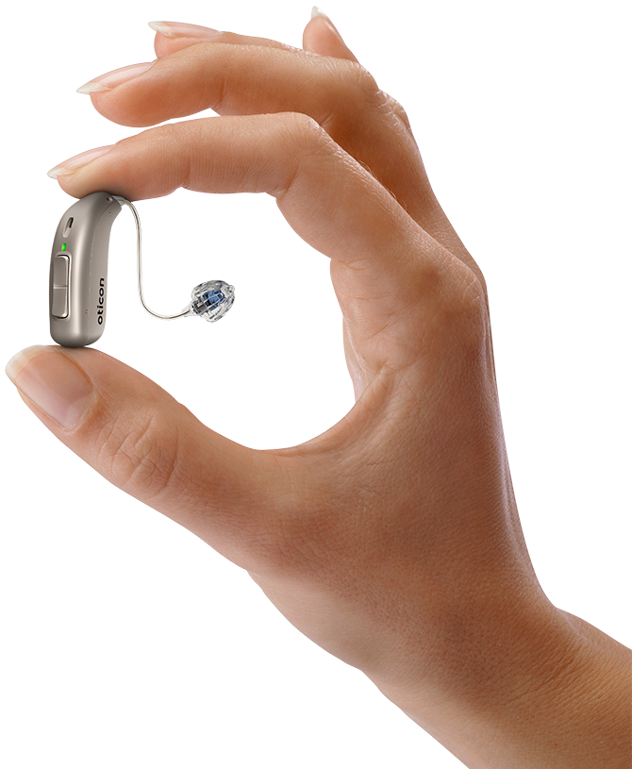 | Here are just a few benefits of Oticon Real:  - BrainHearing™ technology: Helps your brain recognize and balance all types of sounds, allowing you to remain focused, engaged, and sharp  - More choices: Both rechargeable and disposable battery options, plus 9 colors*, so you can choose the style that best fits you  - Connectivity to your digital world: High-quality streaming from iPhone®, iPad®, and select Android™ devices**— helping you stay connected to your favorite devices
Your hearing is important to us and we always want to make you aware of the latest advancements in technology that could benefit you.

Call us at {{clinicPhoneNumber}} to schedule an appointment and discuss a risk-free trial of Oticon Real. We look forward to seeing you—and to helping you take the next steps to even better hearing.

Sincerely,

{{signer_firstname}} {{signer_lastname}}, {{signer_qualifications}}
{{signer_jobTitle}}

